HAWLEY CEMETERY BURIALS

Date of Funeral:
Name of Deceased:
Lot Number: Grave Number:
Cemetery Section: SOUTH NEW OLD _______
Funeral Home:
Time of Service:
Expected Delivery Time:

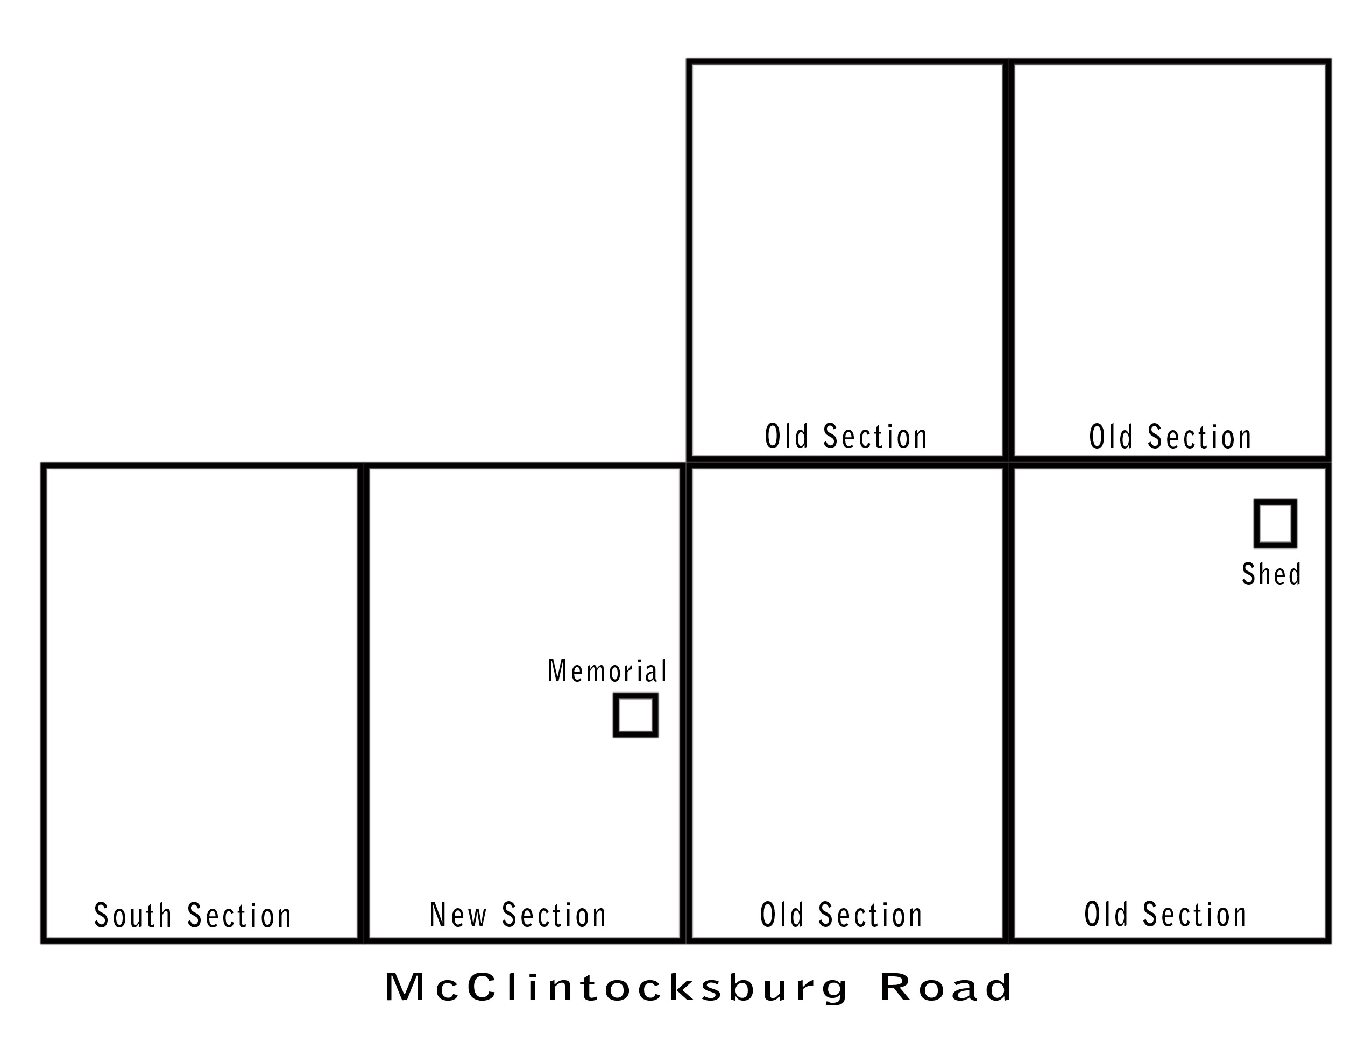

Comments:

